The International Centre of Advanced Materials Science and Electron Microscopy is announcing the International Autumn School on

Microscopy of Tomorrow´s Industrial Materials

to be held from October 3rd to October 7th, 2005 in Berlin-Adlershof, Germany.

The International Centre celebrates its 30 anniversary in 2005. The school provides a platform for bringing together especially younger scientists (PhD students, Post docs) from Middle/ Eastern and Western Europe. They are encouraged to apply for participating in this school. The participants have the opportunity to listen to talks of internationally renowned scientists and to have lively discussions with them. Furthermore, the young scientists are encouraged to present their own work in the form of posters during the school. Extended abstracts will be published on the website of the school.
The school is open for all people interested in advanced materials development. Attendees need not necessarily be electron microscopists.

Location

The Autumn School will be held in the lecture hall of the Faculty of Mathematics and Natural Sciences I of the Humboldt University of Berlin at the campus in Berlin-Adlershof.

Application procedure

Scientists, especially younger ones (PhD students and Post docs), from all over Europe are welcome and encouraged to apply. It is recommended that participants present a poster at the school. Please, send your application letter to

Dr. H. Kirmse
Humboldt University of Berlin
Institute of Physics
Chair of Crystallography
Newtonstrasse 15
D-12489 Berlin
Germany

The registration fee is 90 €.

Financial support

Younger scientists from Middle/Eastern European countries may receive financial support. For application, please submit:

- application form (download:
http://crysta.physik.hu-berlin.de/as2005)
- short curriculum vitae
- half page abstract
- list of publications
- two letters of support from supervisors or senior colleagues

If financial support is granted, accommodation will be free. In addition, about 70 % up to a maximum value of 200 € of the travel expenses, via the most economic means to reach Berlin, will be reimbursed to people from selected countries. Furthermore a daily allowance will be granted.

In order to be considered, complete applications must be received by June 15th, 2005. All applicants will be informed of the outcome by August 1st, 2005.

Accommodation

Accommodation should be booked individually by the participants. A number of hotels is located near to the venue of the Autumn School. For participants receiving financial support the accommodation will be arranged by the organisers.

Topics
- Aberration-corrected TEM
- Advanced TEM-techniques in semiconductor industry
- TEM of semiconductor quantum structures
- In-situ studies by EM and AFM
- Alloys: design, properties, processing
- Nickel based superalloys: microstructure, properties, anisotropy
- Ferroelectric nanostructures: preparation methods, microstructure, and physical properties
- Nanoparticulate composites of metal/oxide and semiconductor/oxide materials
- Thin films: growth, characterization

Invited Speakers
- M. Alexe / Halle
- F. Appel / Geesthacht
- P. Barna / Budapest
- J. Dutkiewicz / Krakow
- U. Glatzel / Bayreuth
- D. Hesse / Halle
- H. Hofmeister / Halle
- A.V. Latyshev / Novosibirsk
- E. List / Graz
- U. Muehle / Dresden
- G. Radnoczi / Budapest
- K. Urban / Juelich
- M. Weyers / Berlin
- P. Werner / Halle

Advisory Board
- A.L. Aseev / Novosibirsk
- A. Claverie / Toulouse
- J. Dutkiewicz / Krakow
- L. Frank / Brno
- U. Gösele / Halle
- F. Hofer / Graz
- H. Hofmeister / Halle
- J. Hutchison / Oxford
- W. Neumann / Berlin
- G. Radnoczi / Budapest
- R. Schlögl / Berlin
- H.P. Strunk / Erlangen
- D. Su / Berlin
- J. Urban / Berlin

Organizing Committee
- A.L. Aseev / Novosibirsk
- F. Hofer / Graz
- J. Hutchison / Oxford
- G. Radnoczi / Budapest
- H.-P. Strunk / Erlangen
- P. Werner / Halle
- W. Neumann / Berlin
- H. Kirmse / Berlin
For more details see:
http://crysta.physik.hu-berlin.de/as2005
or send an e-mail to
autumn-school@physik.hu-berlin.de
Humboldt University of Berlin

Institute of Physics
Chair of Crystallography
Newtonstrasse 15

D-12489 Berlin, Germany
Phone: (+49) 030 20937641
Fax: (+49) 030 20937760

Autumn School 2005 on
Advanced Materials Science
and Electron Microscopy

30th anniversary of
Autumn Schools on
Materials Science and
Electron Microscopy

Microscopy of Tomorrow´s Industrial Materials

Oct. 3rd – Oct. 7th, 2005

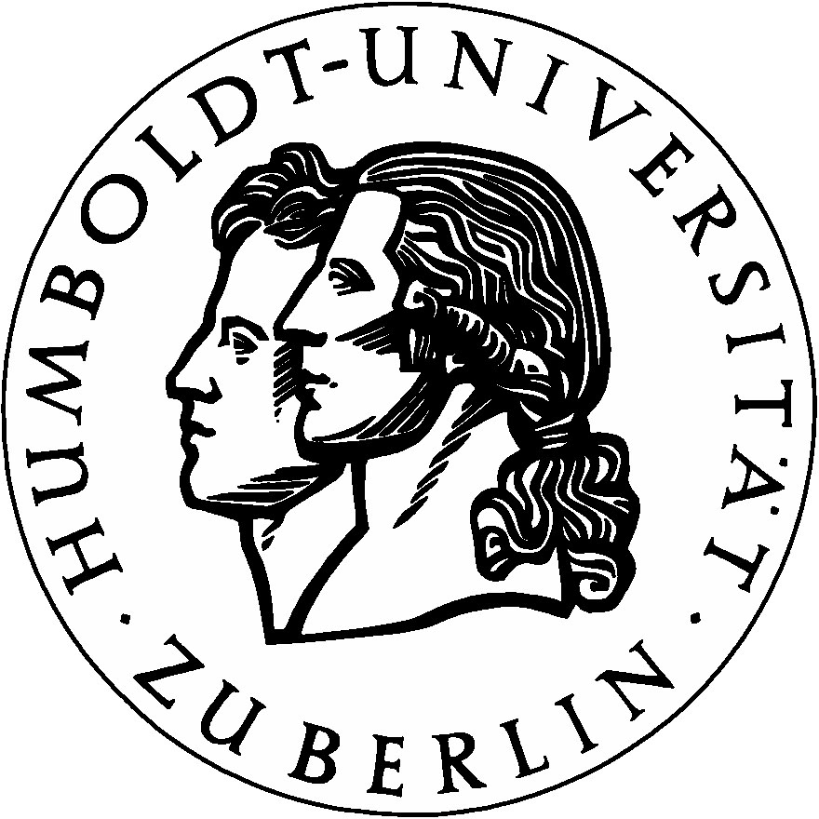

Humboldt University of Berlin
Institute of Physics
Chair of Crystallography

